|  |  |
| --- | --- |
| Name: | Bhumi |
| UID: | 23BCS13453 |
| Subject: | ADBMS |
| Section: | 622-B |

**Code:**

CREATE TABLE Departments (dept_id INT PRIMARY KEY,dept_name VARCHAR(50)

NOT NULL UNIQUE);

CREATE TABLE Courses (course_id INT PRIMARY KEY,course_name VARCHAR(100)

NOT NULL,dept_id INT NOT NULL,FOREIGN KEY (dept_id) REFERENCES

Departments(dept_id));

INSERT INTO Departments (dept_id, dept_name) VALUES

(1, 'Computer Science'),

(2, 'Electrical'),

(3, 'Mechanical'),

(4, 'Civil'),

(5, 'Electronics');

Select * from Departments;

(A) Department’s detail:

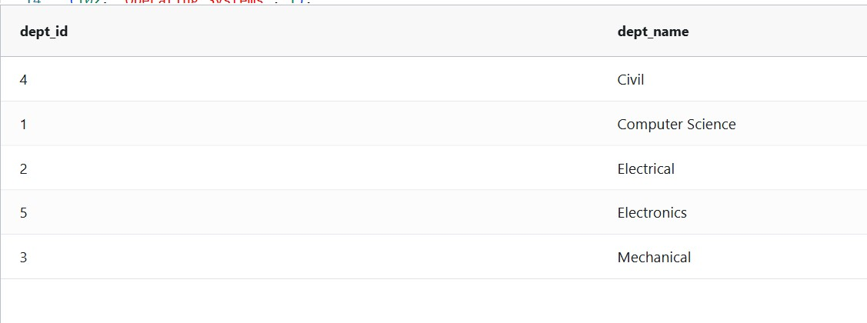

INSERT INTO Courses (course_id, course_name, dept_id) VALUES

(101, 'DBMS', 1),

(102, 'Operating Systems', 1),

(103, 'Power Systems', 2),

(104, 'Digital Circuits', 2),

(105, 'Thermodynamics', 3),

(106, 'Fluid Mechanics', 3),

(107, 'Structural Engineering', 4),

(108, 'Surveying', 4),

(109, 'Embedded Systems', 5),

(110, 'VLSI Design', 5);

Select * from Courses;

(B) Courses detail: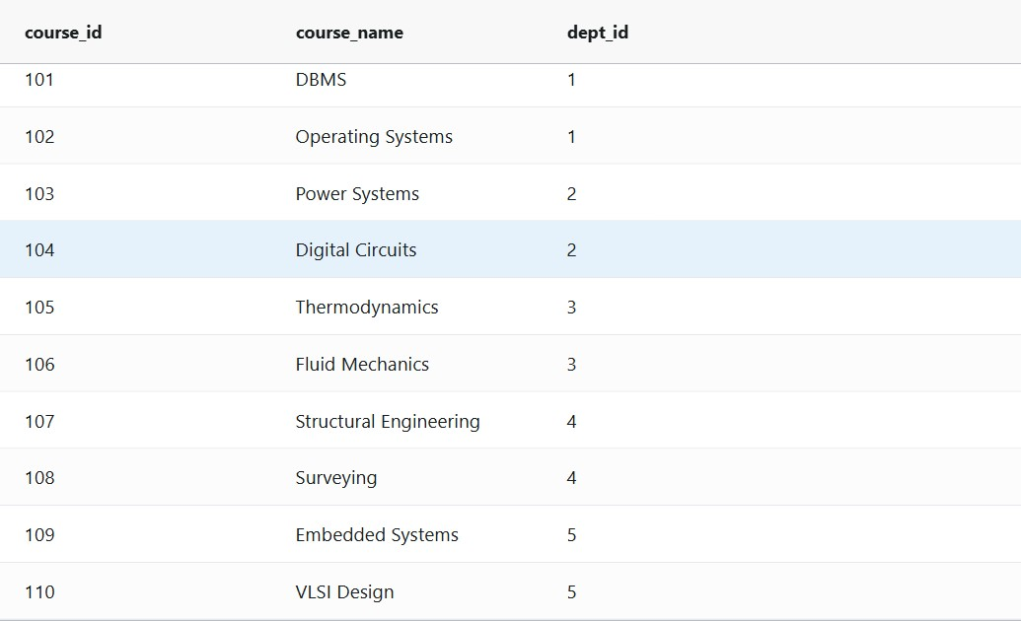

SELECT dept_name

FROM Departments

WHERE dept_id IN (

SELECT dept_id

FROM Courses

GROUP BY dept_id

HAVING COUNT(*) >= 2

);

GRANT SELECT ON Courses TO viewer_user;

(C) Retrieve Departments Offering More Than Two Courses Using Subquery:

